ALLAMA IQBAL OPEN UNIVERSITY, ISLAMABAD
(Department of English Language & Applied Linguistics)

WARNING
- PLAGIARISM OR HIRING OF GHOST WRITER(S) FOR SOLVING THE ASSIGNMENT(S) WILL DEBAR THE STUDENT FROM AWARD OF DEGREE/CERTIFICATE, IF FOUND AT ANY STAGE.
- SUBMITTING ASSIGNMENTS BORROWED OR STOLEN FROM OTHER(S) AS ONE’S OWN WILL BE PENALIZED AS DEFINED IN “AIOU PLAGIARISM POLICY”.

ASSIGNMENT No. 1

(Units 1–4)

Course: Compulsory English II (1424) Semester: Spring, 2010

Level: B.A/BS Total Marks: 100
Pass Marks: 40

Q.1 Given below are two topics. Choose any one topic and write a comparison and contrast paragraph, discussing the similarities and dissimilarities. (20)

- Motor bike and Car.
- Village and City.

Q.2 Whatever happens around us has reasons or causes. The recent increase in the oil price has affected our daily income. Follow the example and then continue writing a paragraph of 250 words following the cause and effect techniques, discussing how far the increase in the oil price has effected our lives. (20)

Example: The increase in the oil price has resulted in inflation in the country……..

- Oil Prices History and Causes
GLOBAL economy has experienced three big oil shocks, during recent five decades. First time in 1973, when oil export has been stopped by OPEC countries in response of Arab-Israel war. Because of less production oil prices jumped from $4.15 in 1973 to $9.07 in 1974. In this oil shock, oil prices make new records and its impacts are clear and seeable in economies of all countries of the world. An oil price has resulted in inflation in our country. The economy is declining day by day. It is very hard to cope with this economical crisis.
- Effected on our daily income
In an economic sense, an oil shock is defined as increase in oil prices large enough to cause a significant decline in global economy. The 1973, 1979 and recent episode both qualify as oil shock by the definition.
Oil price changes affect economic activities such as growth, inflation, trade balance, and so on. It is generally agreed that oil price increases lead to sluggish economic growth. Higher oil prices affect the global economy through a variety of channels. In the case of oil price increases, there will be a transfer of income from oil consumers to oil producers. On an international level, the transfer is from oil importing countries to oil exporters, and oil exporters tend to expand demand only gradually. It will affect income redistribution of the global economy.
Oil prices have effected even on smaller level like small industries, Factories, Mills, power plants. Due to rapid prices our daily life has effected badly. Daily food items and other common items are now available at very high prices in markets. Living of poor people or even middle families are suffering from these high prices. The other major effect of oil prices is on our transpiration. Transpiration of goods is highly costly due to this prices are very high. The traveling has also effected due to these oil prices.

Q.3 Imagine that you are an Editor of a leading Pakistani English newspaper. Write down a short Editorial (not more than 150 words) on any one of the following: (15)

a. Problems Faced by Women in Villages.
b. Literacy in Pakistan.

Q.4 Choose a letter to Editor from an English newspaper and write down answers of the following questions.

a. What does the writer want to convey? (5)
b. What is tone of the letter? (5)

Q.5 Following are the two headlines. If you are report writer, how would you write reports about these headlines? (20)
(Any one)
a. Global warming ______ a threat to life.
b. Government bans smoking at public places.

Government bans smoking at public places.

Q.6 What are stated and implied meanings? Give definitions with at least three examples each. (10)
Ans:
- Stated
Definition
A condition or mode of being, as with regard to circumstances:
Examples:. Affirmed, Confirmed & Declared

- Implied
Definition
Suggested without being stated directly
Examples:. Indirect, Oblique& Obscure

Q.7 What is expository text? Give example. (5)

Definition
Expository writing is a type of writing, the purpose of which is to inform, explain, describe, or define the author's subject to the reader. Expository text is meant to deposit information and is the most frequently used type of writing by students in colleges and universities. Thus exposition includes explanation of ideas, facts, processes, arguments, etc, their analyses and interpretation, and the resulting conclusions.
Examples this type of writing are cooking instructions, driving directions and instructions on performing a task
ASSIGNMENT No. 2

(Units 5–9)
Total Marks: 100 Pass Marks: 40

Q.1 Write a detailed and well organized paragraph of 200 words discussing and describing one of the following topics: (10)

- Human Rights in Pakistan.
- Terrorism in Pakistan.

Pakistan’s human rights record has dramatically improved since the reforms that took place after the tenure of President Zia-ul-Haq in 1988. The situation of human rights in Pakistan is a complex one, as a result of the country's diversity, large population approximately 176 million, its status as a developing country and a sovereign, Islamic republic as well as an Islamic democracy with a mixture of both Islamic and colonial secular laws. The Constitution of Pakistan provides for fundamental rights, which include freedom of speech, freedom of religion, freedom of the press and the right to bear arms. These clauses are generally respected in practice. Clauses also provide for separation of executive and judiciary, an independent judiciary and freedom of movement within the country and abroad.
Although the civilian government took some positive steps, the overall human rights situation remained poor. Major problems included extrajudicial killings, torture, and disappearances. Collective punishment was a problem, particularly in the Federally Administered Tribal Areas (FATA), which fall under the legal framework of the Frontier Crimes Regulation (FCR). Lengthy trial delays and failures to discipline and prosecute those responsible for abuses contributed to a culture of impunity. Poor prison conditions, arbitrary arrest, and lengthy pretrial detention remained problems, as did a lack of judicial independence. Corruption was widespread within the government and police forces, and the government made few attempts to combat the problem. Rape, domestic violence, sexual harassment, and abuse against women remained serious problems. Honor crimes and discriminatory legislation affected women and religious minorities respectively. Religious freedom violations and inter-sectarian religious conflict continued. Widespread trafficking in persons, child labor, and exploitation of indentured and bonded children were ongoing problems. Child abuse, commercial sexual exploitation of children, discrimination against persons with disabilities, and lack of respect for worker rights remained concerns.
Provincial governments have primary responsibility for enforcing labor regulations. Enforcement was ineffective due to limited resources, corruption, and inadequate regulatory structures. According to the ITUC, labor inspectors exempted certain employers from inspection in Sindh and Punjab. Many workers remained unaware of their rights, especially in the informal labor sectors.

Q.2 Write/design/compose advertisement from the Forest Division to inform the general public about the hazards caused to the environment by cutting of trees (deforestation). Mention some measures taken by the Division and ask the public for cooperation. (20)

Q.3 Read the following short story and then answer the questions that follow: (20)

It was 80 degrees in the shade. A man wearing a heavy army jacket, a pullover wool cap, and dark sunglasses walked into the City Bank Islamabad at the corner of Blue Area.

The man walked up to the teller and held up a hand grenade for all to see. He said, “Give me all your money, all the money in this bank, right now!”

Everyone in the lobby screamed and started running, even the security guard. Nervously, the young female teller handed the man three big bags loaded with cash. He walked out the door. A second later, one of the money bags exploded, covering him with red dye. He yelled in pain and surprised, and started pacing around in circles because he couldn't see where he was going.

He couldn’t see, but he could hear. He heard the police siren get closer. Then he heard the police tell him to get down on his stomach on the sidewalk and put his hands behind his back. They handcuffed him and placed him in the back of the police car.
Seeing the hand grenade on the sidewalk, the police told everyone to get back. They sealed off the whole block and called the bomb squad. The bomb squad came and examined the hand grenade. Then they laughed. They told the police it was a fake. The hand grenade was actually a harmless dummy, something a 12-year-old might play with.

The police chuckled. The bank employees returned to work. The bank customers returned to their lines. The bank robber, hopefully, would never return

  - What was the temperature?
Ans. The temperature was 80 degree.
  - What kind of eyewear was the man wearing?
Ans. The man was wearing a heavy army jacket, a pullover wool cap and dark sunglasses.
  - Which bank did the man walk into?
Ans. The man walked into the City Bank.
  - What did the man hold up for all to see?
Ans. The man held up a hand grenade for all to see.
  - What did everyone in the lobby do, even the security guard?
Ans. Everyone in the lobby screamed and started running, even the security guard
  - Which corner is the First American Bank at?
Ans. The American Bank is at the corner of Blue Area.
  - How many big bags of cash did the man receive?
Ans. The man received three big bags of cash.
  - What happened a second after the man walked out the bank door?
Ans. A second later, one of the money bags exploded.
  - What was the man covered with?
Ans. The man was covered with red dye.
  - Where did the police put the man?
Ans. The police placed him in the back of the police car.

Q.4 Read the following poem and write down the summary of the poem. Use dictionary to understand meanings of the difficult words. (20)

Hope is the Thing with Feathers
By: Emily Dickinson

“Hope” is the thing with feathers
That perches in the soul
And sings the tune without the words
And never stops at all,

And sweetest in the gale is heard;
And score must be the storm
That could abash the little bird
That kept so many warm.

I’ve heard it in the chillest land
And on the strangest sea,
Yet never, in extremity,
It asked a crumb of me.

A detailed Summary of Hope is the Thing With Feathers by Emily Dickinson

In "Hope" is the Thing With Feathers, she uses many of her techniques to make the poem more lively and fun to read.
In this poem, Emily Dickinson uses an irregular rhyming scheme of "abcb." This means that in each of the three stanzas, the second and the fourth line rhymes with each other. Along with her irregular rhymes, she uses irregular punctuation to direct her readers into certain flow of the poem. In this poem, she uses many hyphens to emphasize the expenditures. This gives the poem the effect of soft, slow, feather floating in the air. She also capitalizes key words in the middle of sentences that are main symbols or have a big effect on the poem. This also points the reader's eyes to these words so that they will pay closer attention to them.
Emily Dickinson compares the "Hope" to "the thing with feathers" or simply birds. This implies that hope has the ability to take someone up, or to heaven. The birds have feathers and therefore, are able to fly upward. This shows you that with hope, someone could get closer to heaven, or happiness. Hope is something that can lift someone's soul or spirit up. She is also saying that hope or faith is the only thing
Q.5 See this travel brochure and then write in a form of short paragraph what information this travel brochure is giving. Don’t miss any details. (10)
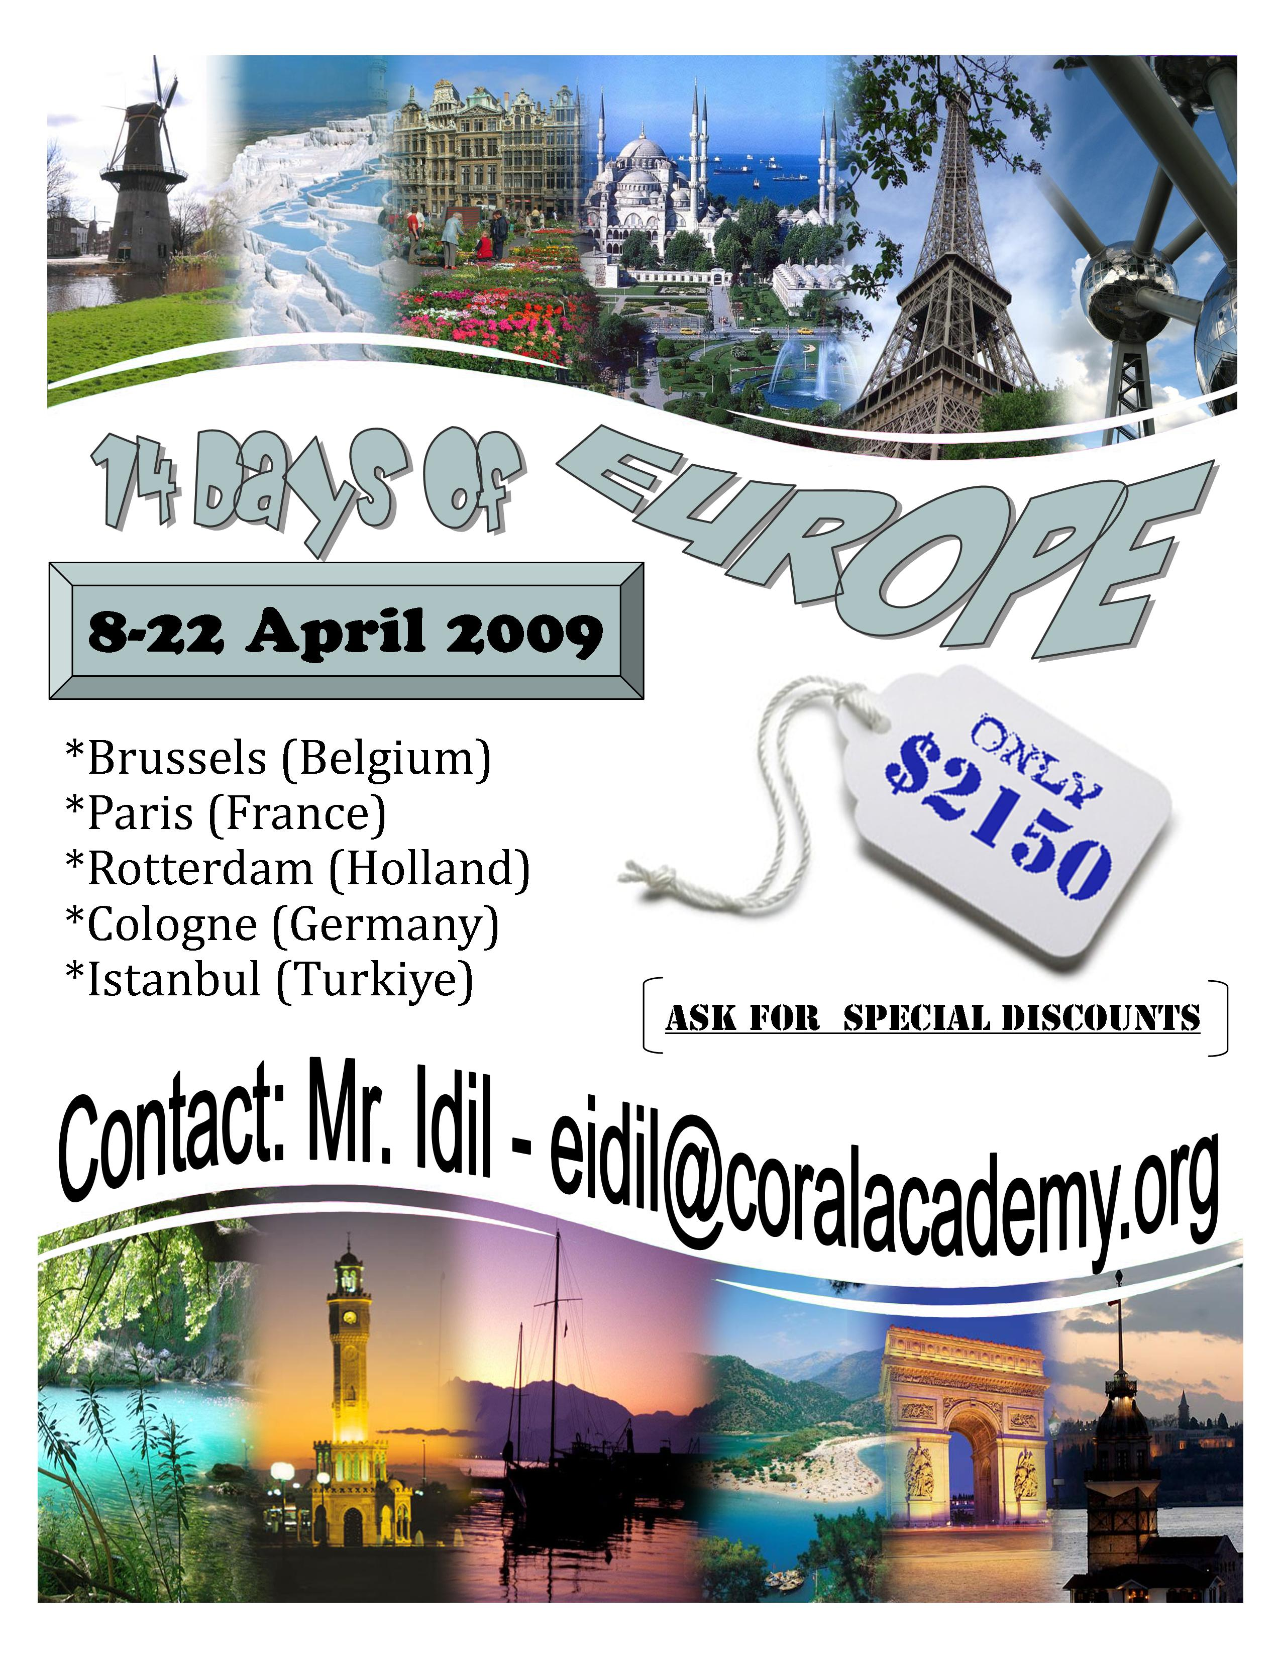
Ans. This brochure is advertising package of travel air line. The air line is providing a package of tour to the Europe for 14 days from 8-22 April 2009. The tag is showing discount price for this tour which is only $ 2150. They have also mentioned name of those required places and countries as given below:

- Brussels (Belgium)
- Paris (France)
- Rotterdam (Holland)
- Cologne (Germany)
- Istanbul (Turkiye)

The interesting thing and beautiful picture and sceneries are also shown in the brochure to attract the reader. These pictures are very having good effect on reader mind and they are spelled bound to visit such delightful and superb places.

In the end they have give the contact detail also as there E-mail address is also online booking and further information.

Q.6 Find the meaning of the underlined word in each sentence according to the context in which it is used. Choose the best answer for each question. (10)

1. She had often come into conflict with her mother-in-law.
a) Announcement b) attainment c) argument

2. The old woman’s blunt questions embarrassed her, making her tongue-tied.
a) Admit b) ashamed c) loathe

3. We just need a couple more chairs so everyone can sit down.
a) one b) two c) three

4. Please, Uncle, give me a piggyback!
a) a ride on someone back or shoulder
b) a small bag
c) people who arrived to settle in Lahore.

5. Sana does not like to eat papaya or carrots, which is high in vitamin A, so she lacks it. Her mother keeps telling her that an inadequate supply of vitamin A can lead to blindness.
a) too big b) not enough c) full

Q.7 Fill in the blanks with appropriate words. Choose from the list of words given with each sentence. (10)

a. I used to be so ________, but now I worry about everything.
Carefree
Nervous
Sleepy

b. I am so ________ about starting university this year! I can't wait!
Depressed
Enthusiastic
Smart

c. I've been pretty ________ with my job, so I'm looking for a new one.
Unhappy
Satisfied
Happy

d. I was ________ with the architecture in Rome - It was amazing.
Content
Excited
Impressed

e. Naila is very ________ for all the help you have given her.
Unhappy
Great
Grateful

